**Registration for OPEN Courses**

1. Check your email account for an email from OPEN- Online Professional English Network.
2. Click on the link provided to you in the email, and you’ll be directed to a page with a you’ll consent form approval.
3. Check the box for consent to privacy notice from OPEN and click ‘submit’.
4. You should see a ‘create your account’ window. Please choose a password that is minimum 8 characters and maximum, needs to contain lower case letters, upper case letters, numbers and symbols like # $ % & = ()- _ . etc’.
5. Do not use your personal account ending with @gmail.com or @hotmail.com when asked to provide a username. it should end with @openenglishprograms.org.
6. Click create account
7. You should be directed to another window with the following script in green:

‘your user account has been successfully created ….please continue by clicking the “log in” link below’.

This message or window verifies that you indeed created an account successfully.

1. Click log in, in order to try your new account and password and enter the system.
2. Please insert your full account that you just created with the ending of @openenglishprograms.org. and click next.
3. Please choose an account recovery method to reset your password. Please choose whether that is done via phone or an email. Note: If you choose the phone option, please follow these steps: choose right country, enter phone number, and choose whether you’d rather be sent a text message with a code or have the website call you with the code that allows you to reset your password in the future to ensure you always have access to OPEN website while you are taking the course. And click next.

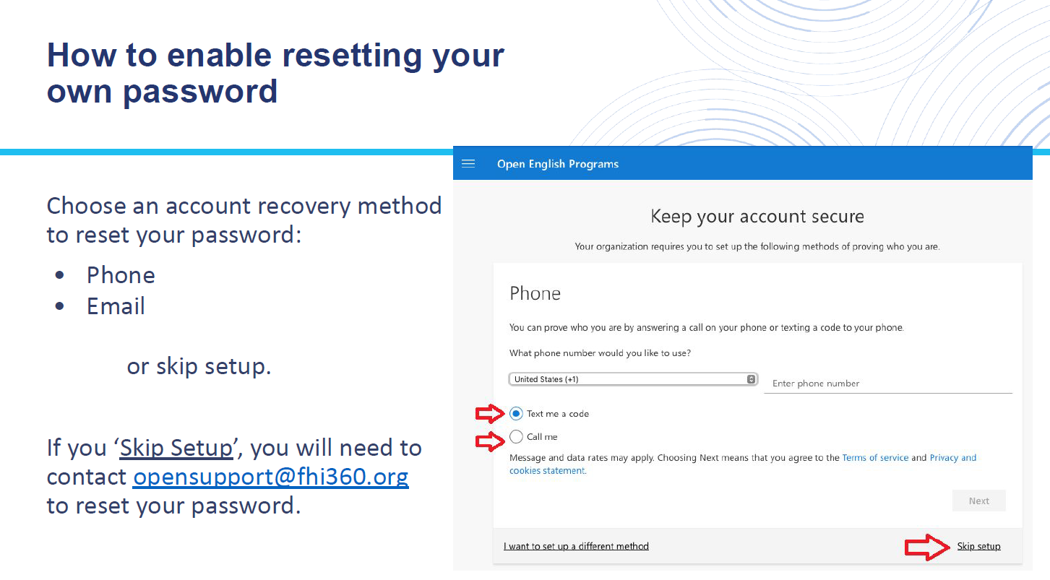

1. after last password resetting window, you should be directed to another page to complete your registration process. Please fill out your first name, last name, your name as you wish for it to appear on OPEN certificate, country of residence, citizenship (American citizens cannot participate or take OPEN courses), city of employment and if you will be living in that country throughout the entire term of OPEN course. Click submit.
2. Select course choices. If you have not been nominated for a specific course, you will have the option to select your three preferred courses from the list of courses provided in the current window. You will be enrolled in 1 of those 3 courses. Click submit.
3. In order to complete your registration, please click on “complete registration” to log in to Canvas.
4. Use username and password you created for OPEN, log into Canvas course site so you can be invited to your OPEN course.
5. Then you should receive an email from OPEN titled “OPEN Registration Completed”. When you see this email, you should know that your registration was successful. It should have your log-in username (openenglishprograms.org account), a link to update your information, and a link to access the OPEN website.

If you do not receive a confirmation email, please contact us for support at:

opensupport@fhi360.org

alayanhi@state.gov