Middle East in Danger

State Of Exception Workshop
21st of July-Graduate College Social Hub

First Panel:

State of Exception, its foundation and definition in Law and politics.

What’s At Stake in the Exception? The State, The Umma and Sovereignty in
the State of Exception.
Simon Mabon

In the aftermath of the Arab Uprisings, states across the Middle East faced a number of serious challenges to reconcile tensions between regime and society, whilst also ensuring their survival amidst rising regional pressures. The onset of violent protests in Syria, Iraq, Bahrain and Yemen would also have broader ramifications within those states not hit by protests. Within this climate, regimes attempted to retain power through a range of different ways, including by framing events as security challenges and by using political and legal channels to prevent the emergence of protest movements. One such mechanism was to declare a state of emergency, which, when placed within political debates about the nature of statehood, is understood as a state of exception.

In this paper I seek to do two main things. First, to provide an overview of the concept of the state of exception and its application in the Middle East. Whilst a great deal of work has been done on the concept of the state of exception and the creation of bare life that follows, very little consideration of the consequences of the state of exception in the Middle East, which poses a number of theoretical and empirical questions. Second, I seek to bring in a more normative or informal dimension to considerations of the state of exception. Although formal structures (found in law and institutions) play a prominent role within the creation of the exception, I argue that we must also consider the role played by informal structures – such as religion and tribalism – to gain a more nuanced understanding of the concept, along with how people then reside in bare life.

Short Bio
Dr Simon Mabon is Director of the Richardson Institute and Lecturer in International Relations at Lancaster University. He is the author of Saudi Arabia and Iran: Soft Power Rivalry in the Middle East(2013), and co-author of The Origins of ISIS (2017), Hezbollah: From Islamic Resistance to Government (2015), and British Foreign Policy after World War 2 (2017). He has published in a range of journals including British Journal of Middle East Studies, Third World Quarterly, Studies in Conflict and Terrorism, Middle East Policy, and Religion, Politics and Ideology. He regularly comments on Middle Eastern affairs to international media outlets.

No Exceptions: Authoritarian Legality. UK Counterterrorism and the new Rule of Law

Christos Boukalas

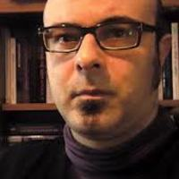
This paper produces a, surprisingly rare, comprehensive outline of UK counterterrorism legislation and assesses it implications for the rule of law. Contrary to exception-based approaches, it argues that counterterrorism does not institute an (permanent) exception, but ‘the new normal’: a durable and profound reconfiguration of rule of law normality.
UK counterterrorism legislation comprises 8 dedicated parliamentary Acts and a host of provisions scattered across Acts addressing crime, criminal justice, immigration, finance, and intelligence. Given its sheer volume and disparity, an exhaustive presentation of UK counterterrorism law would be impossible within the confines of a brief paper. Instead, to provide a comprehensive overview of it, this paper identifies the main trends of counterterrorism law, exemplifies each by a couple of specific provisions, and analyses them from the point of view of criminal law. Namely, it discusses the temporal expansion that counterterrorism introduces to criminal law; the open-ended character of its offences; the bypassing of criminal law through parallel, hybrid and administrative, procedures; and the re-orientation of criminal law towards pre-emption that constitutes the overarching trend that counterterrorism installs in criminal law.
The paper assess the implications of this pre-emptive turn for the rule of law. It does so by distinguishing between three articulated but analytically distinct elements that comprise the law: legal content, the logic that motivates the law, and the institutional framework within which the law is produced and implemented. Here, counterterrorism law represents a paradox: while both its content and logic run contrary to the rule of law, its institutionality is fully inscribed in the confines of the latter. To account for this contradictory positioning of counterterrorism vis-a-vis the rule of law, the paper concludes that the latter signifies the advent of ‘authoritarian legality’: a reconfiguration of the rule of law that turns its juridico-political principles on their head without ever breaching it.

Short Bio

Dr Boukalas is developing research which examines the strategic turn by the British state towards capturing crime before it occurs. His project, The Pre-emptive Turn in UK Law is sponsored by the Journal of Law and Society and will focus on the impacts in criminal law, the temporalities of justice and lawyers’ practice, and on the structure and operational mode of policing.
Dr Boukalas has a PhD in state theory, and expertise in contemporary American counterterrorism policy. He has accomplished an ESRC-sponsored research project on Counterterrorism Policy: Law, the State, and Implications for the Polity (Centre for Law and Society, Lancaster University).
His research interests include political and state theory, counterterrorism, theory of law, criminal law, and theory of democracy. He has published several articles and book chapters in these areas. His book Homeland Security, its Law and State – a Design of Power for the 21st Century will be published by Routledge in April 2014. It examines US counterterrorism policy, and its impact on the form of law and on political culture and institutions.

Second Panel: Egypt and the State of Exception between Law and Politics

The State of Exception in the Arab World:
Still a “Paradigm of Government”?

Francesco Biagi

Arab countries are sadly known for abusing of the state of exception. Morocco, for example, experienced a state of emergency under King Hassan II during the period 1965-1970, when the 1962 Constitution was suspended. In Egypt, a state of emergency was declared in 1967 and lasted until 1980. Then, after a break of 18 months, it was re-imposed in 1981 and lasted until May 2012. States of emergency have also been recently declared in Egypt following unrests and terroristic attacks (for example in 2013 and in April 2017). In Jordan King Hussein imposed martial law in 1967 and lifted it in 1992. The state of emergency was in place in Algeria for 19 years (from 1992 to 2011), and in Syria for 48 years (i.e. from 1963 to 2011). Therefore, in the MENA region, a provisional and exceptional measure was transformed – to use the words of Giorgio Agamben – into a “paradigm [or] technique of government”.
In this paper I will discuss how the new (or amended) Arab Constitutions regulate the state of exception, and I will argue that they have addressed the abovementioned problem of the “normalization of the exception” only partially. Indeed, in most of the cases the Head of State continues to have the power to declare the state of exception without effective limitations, thus paving the way for potential abuses. I will also argue that the Constitution which limits in the most effective manner the presidential power to declare the state of exception is the 2014 Tunisian Constitution, especially in the light of the fact that the Constitutional Court has been assigned the task of reviewing the state of emergency declared by the President. Indeed, comparative examples (e.g. Colombia) show that this can be a very effective tool to prevent the President from abusing of this power.

Short Bio

Francesco Biagi is a Postdoctoral Research Fellow in Comparative Public Law at the University of Bologna’s School of Law, and Researcher at the Center for Constitutional Studies and Democratic Development (a partnership between the Johns Hopkins University SAIS Europe and the University of Bologna). Biagi obtained a Ph.D. in Constitutional Law from the University of Ferrara after graduating in Law from the University of Bologna. From October 2015 to January 2017 he was a Senior Research Fellow at the Max Planck Foundation for International Peace and the Rule of Law (Heidelberg), where he now works as a consultant. In 2015 and 2017 he was Visiting Professor at the College of Law of the University of Illinois. He is the author of a book on the role of Constitutional Courts in the processes of transition to democracy (Corti costituzionali e transizioni democratiche. Tre generazioni a confronto, il Mulino 2016), as well as several articles and book chapters focusing on transitions to democracy, constitution-building, forms of government, constitutional justice, electoral justice, and federalism. He also coedited a book with Justin O. Frosini on “Political and Constitutional Transitions in North Africa: Actors and Factors” (Routledge 2015). In 2017 he obtained the National Scientific Qualification to become Associate Professor of Comparative Law.

States of Exception and Emergency in the Post Arab Uprisings Middle East: the case of Egypt

Lucia Avdovini

On January 25th, 2011, chants asking for “bread, freedom, and human dignity” resonated across Egypt, marking the beginning of the popular uprisings that would lead to the deposition of long-standing dictator Hosni Mubarak. Together with the calls for basic human rights, one of the main grievances behind the popular protests was caused by the increasing restriction of the political space, upheld by an Emergency Status that had been ruling the country almost uninterrupted since the 1967 Six Days War. Over the course of almost 44 years, Egypt’s State of Emergency had been used to suspend the rule of law and to enhance the power of the executive, drastically reducing the political space and compromising the very notion of citizenship.

While this State of Emergency was temporarily lifted following Mubarak’s removal, the al Sisi’s government re-issued it a few weeks after gaining power through the July 2013 coup d’etat. Therefore, this paper argues that Egypt’s perpetual State of Emergency can be read through the lens of Agamben’s State of Exception, as constitutional powers have been repeatedly abused in order to maintain the rule of political elites. To do this, the paper unpacks the historical relationship between the State of Emergency and Egyptian politics, with a special focus on the al Sisi’s government, as a way to track how this phenomenon is being used to establish and maintain SCAF’s military dictatorship.

Short Bio
Lucia Ardovini has recently completed her ESRC-funded PhD in International Relations in the Department of Politics, Philosophy and Religion at Lancaster University. Her thesis focuses on the Egyptian Muslim Brotherhood’s year in government and assesses the implications of their deposition for the wider, contemporary understanding of Political Islam. Lucia is now a Post Doctoral Research Fellow at the Swedish Institute of International Affairs, where her research focuses on the exploration of contested spaces and of contemporary challenges to notions of authority and sovereignty in the MENA region. Lucia is also a Richardson Institute’s Research Fellow.

Third Panel: Palestine and the State of Execption between law and Politics

A Perfect Marriage? How a Political System and the Political Reality Creates a State of Exception

Sanaa Alsarghali
Since the Constitution (the Basic Law) was formed in Palestine in 2003, the Palestinian government has been forced to experiment with political systems that can best fit its unique political reality. Palestine’s evolving political system, which is based on an inadequate Basic Law, in parallel with the changes of its political reality has now reached a point of stability since 2007. Unfortunately, this now stable symbiotic relationship between the political system and the political reality is one, which favors the prolonging of the state of exception. This stability can be explained, in part, with Carl Schmit famous statement: that it is the sovereign “who decides on the state of exception”. Here Schmit is hinting at the inherently unconstitutional foundation of ‘State of Exception’, which is currently in effect today in Palestine due to the power of its de facto sovereign.
The state of exception has remained a vague and undiscovered area in public law and is often associated with the ‘state of emergency’ and the ‘state of necessity’ two tools that can be used to create the state of exception. These two, often constitutionally guaranteed tools, are often used to by a president to obtain exclusive powers for a limited duration in certain specific circumstances. Prior the Arab Spring most Arab states were in a permanent state of exception due to the power of the sovereign had to extend and define these particular conditions to their own ends, echoing somewhat Schmit’s emphasis on the sovereign during the state of exception.
Unfortunately, Palestine is no different to this tendency towards centralization of powers in the Middle East. Thus, this paper intends to explore the nature of the current symbiotic relationship between Palestine’s political reality and its semi-presidential political system that has led to its current extended condition that can be referred to as the state of exception. Using a mix of constitutional theory and political science this paper therefore asks: how was power decentralized between the president and the prime minister? Should any prime minister be forced to act as the president’s puppet to stay in office? Does the president have the power to appoint an emergency government to start with? What is the role of the newly established Constitutional court during the state of exception?

Short Bio

Sanaa Alsarghali is the first Palestinian female holding a PhD in constitutional law in Palestine from the UK. Sanaa just started lecturing at an-Najah Law school in Palestine. She also holds an LLM in law from Durham University and a BA in Law from An-Najah University.
Sanaa was awarded a full scholarship from An-Najah University to study constitutional Law in order to participate in the constitutional building in Palestine after her return. Her PhD thesis focused on the presidential concentration of powers within the Palestinian Basic Law. She is a strong believer of the need for an active constitutional court in Palestine that could guarantee the application of any future suggestions related to the Basic Law or the future constitution.
Sanaa is an Annenberg Oxford Media Policy Institute’s alumni. In 2016 She was elected as the Chairwoman of TAM, an NGO that intends to change the stereotypical image of the Palestinian women in the Media.This makes Sanaa the youngest Chairwoman of an active NGO in Palestine. Previously, she worked as a TV presenter in Al Fajer TV local station. Her social and political talk show 'Tam Time' was screened on the Palestinian National TV for two years. Sanaa also helped in producing several documentary movies that focus on the protection of social rights.

Protracted (humanitarian) emergencies and occupation-authoritarianism: The double sacrifice of human rights in Palestine

Alice Panepinto

Taxi driver in Hebron: what is your job?
Alice: I am a human rights and international law researcher
Taxi driver: Wayn huquq al-insaan? wayn qanun dawli? Ma fii!
[Where are human rights? Where international law? Nowhere!]

The adverse effects of states of emergency and exception on human rights standards has long been discussed. When executive authorities accentuate and centralise power, the balance between individual and state is destabilised, and human rights are exposed to direct and indirect erosion. The (mis)use of the counterterror rhetoric exacerbates the weaknesses of legal protections of human rights further – including in fragile states seeking to quash opposition and criticism, as well as in strong military powers seeking to entrench geopolitical positions. In Palestine* human rights of Palestinians are increasingly sacrificed through the joint effects of military occupation (a legal regime ordinarily temporary and exceptional now in its 50th year), political authoritarianism (in the context of, but not only due to foreign military occupation) and man-made humanitarian emergencies of increasing severity and complexity (grossly mismanaged by the international community). This paper will reflect on the human rights restrictions imposed by three tiers of concurring states of exception and emergency (understood factually as a mutation of ordinary rule of law), determined by (1) the Israeli military and civilian authorities (through the administration of the occupation in the frame of settler-colonialism), (2) the Palestinian Authority (through the turn to authoritarianism, and the Fatah-Hamas struggle) and (3) the international humanitarian and development community (donors) (through the channelling of economic resources and political support in ways that evade common article 1 of the Geneva conventions – obligation to “respect and ensure respect” of IHL). This paper will consider how human rights remain an elusive concept in Palestine, in stark contrast with the rights discourse adopted by all three tiers considered here.

* For the purposes of this paper, Palestine is understood according to the established UN position to include East Jerusalem (unilaterally annexed by Israel in 1967 – in violation of international law), West Bank (occupied by Israel in 1967 – in which grave breaches of IHL occur) and Gaza (under blockade by Israel and Egypt since 2007 – in which grave breaches of IHL occur). This does not seek to discredit vital critiques to the accepted UN position, in light of pre-1948 facts on the ground, Palestinian cultural heritage and right of return.

Short Bio

Alice Panepinto is a lecturer in international law and land law at Queen’s University Belfast (Northern Ireland).

Alice’s research and teaching experience spans a range of international law, human rights and human security themes, and adopts a comparative and socio-legal approach with a special interest in the Middle East. Her disciplinary focus has been transitional justice, truth-seeking and accountability after conflict and authoritarianism. Building on her practitioner work in Jerusalem, she also researches international law violations in Palestine-Israel, and in particular how law impacts relationships between people and land in the West Bank. Her project on Al Khan al Ahmar, partly funded by the UK Economic and Social Research Council – Global Challenges Research Fund, has enabled her work and facilitated collaborations outside academia.

Her most recent peer-reviewed publications include “The Right to the Truth in International Law: The Significance of Strasbourg’s Contributions” (Legal Studies, 2017) and “Jurisdiction as Sovereignty over Occupied Palestine: The Case of Khan-al-Ahmar” (Social & Legal Studies, 2016). She is currently writing a book chapter on the notion of authority in international human rights law for an edited collection.

Between 2015-2017 Alice held a postdoctoral research fellowship at the Centre for Human Rights in Practice, Warwick University. She was awarded a PhD from Durham University in 2015 for a thesis on“Relocating Transitional Justice from International Law to Muslim-Majority Legal Systems: Concepts, Approaches and Ways Forward”, which constitutes the basis of a future book project. Alice was a 2014 UN-DESA fellow in human rights in Jerusalem, a visiting lecturer at Hebron University (autumn term 2014) and has worked with international humanitarian/development actors in the region.

The Palestinian Authority’s state of exception and the legitimation of its existence
Emilio Dabed
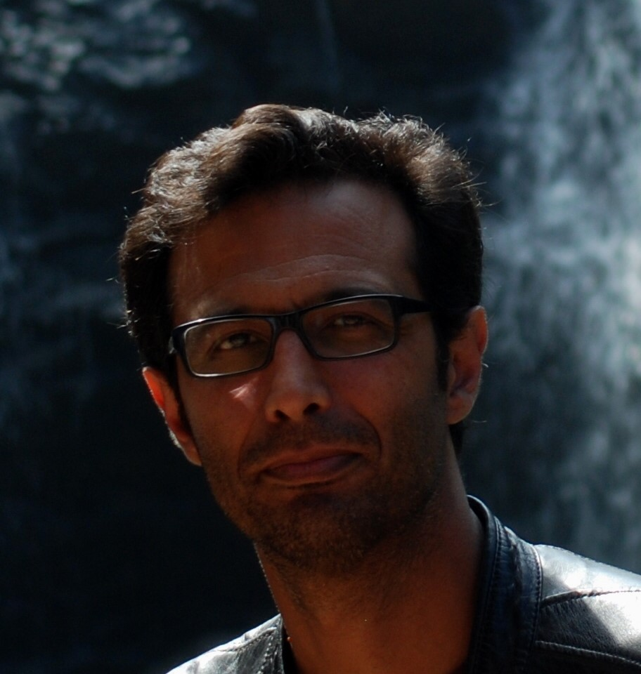
German legal theorists coined the concept of ‘constitutional dictatorship’ to describe a government with ever-expanding powers, almost total power, held by the executive in a technically declared or purported state of exception. This is exactly the situation in which Palestinians are living today. The fact that the PA is not a state and that Palestinians live under occupation does not diminish the pertinence of the expression to describe their political condition. In fact, one could persuasively argue that Palestinians live under a double state of exception. One is the state of exception imposed on them by the Israeli colonial regime, and under which Palestinians are neither citizens-holders-of-rights nor political subjects of any kind but, rather, simply a fact, a threat, bodies ruled by violence normalized in law. The second state of exception is a Palestinian one. It is internal to the PA; it started in 1994 with the inception of the authority but was brought to its zenith after the 2007 split between the West Bank and Gaza Strip, and the legal and practical suspension of its constitutional regime.
From its very inception, PA politics has mirrored the conditions of the state of exception: a political regime in suspension, ever-increasing executive powers, including the monopoly or control of different legislative and judicial authorities, normalized rule by decree, and extraordinary security measures to contain resistance and dissent. However, in recent years PA political practices have evolved from a simple state of exception to the dynamics of a proper ‘constitutional dictatorship’. It is a regime that far from abandoning or suspending law, uses law as an integral part of its strategy to normalize its violence. If this violence is not regulated by law, it is exerted through legal means, and it seeks the law’s legitimacy as a dominant discourse of truth.
The expression ‘constitutional dictatorship’ is extremely useful in understanding contemporary politics, in Palestine and beyond. In the specific case of the PA, ‘constitutional dictatorship’ emphasizes a startling phenomenon, crucial to the understanding of current Palestinian politics: that the entrenchment of the colonial regime, the division within the national movement, the territorial and institutional fragmentation of Palestinians, and the PA’s heightened authoritarianism, have been reinforced, not against the law, but precisely through the PA’s legal structures, and are justified by a perplexing use of the language of rule of law, good governance, and human rights. This use of law and legal discourse have served to legitimize (or treat merely as a technical matter) the PA’s drift toward further concentration of power in the executive, repression, division, and its collaboration with colonial dispossession. These realities have been objectified and reproduced by laws, institutions, and its discursive strategies, which show that law and the language of rights are not at odds with the PA’s practices but, on the contrary, that the authority seems to comfortably speak this language. The PA has colonized and mastered the ‘discursive explosion’ in the juridical field that we witness in relation to Palestine, and skillfully manages to put it at the service of its own reproduction.
This presentation intends to engage with these dynamics by elaborating on a few illustrative examples showing how, within the state of exception, the PA’s brings its own violence into the law as a strategy of legitimation and survival.

Short Bio
Emilio Dabed was born in Chile to a Palestinian family from Beit Jala. He is a lawyer specializing in constitutional matters, international law and human rights, and he is currently a consultant for the Capacity Development in Higher Legal Education project at the Center for International Legal Cooperation Amsterdam-Netherlands, based at An-Najah National University, Nablus, Palestine. Previously, he was the Palestine and Law Fellow and Adjunct Assistant Professor of Law at Columbia University Law School-Center for Palestine Studies 2015-2016; between 2014-2015 he was the director of the International Law and Human Rights Program at Al-Quds/Bard College, Jerusalem, where he taught between 2011 and 2015. Dabed holds a Ph.D. in Political Sciences from the Institut de Sciences Politiques d'Aix en Provence, and IREMAM-CNRS (Institut de Recherche et d’Etudes sur le Monde Arabe et Musulman-Centre National de Recherche Scientifique, Aix-en-Provence, France) on the constitutional process in Palestine. His latest research looks at the relations between legal processes and discursive practices, on the one hand, and political and social changes, subjectivity, and identity formation on the other. His work aims to shed light on the role that juridical phenomena play in sociological and anthropological questions and, more specifically, on the disciplinary powers of law and the discourse of (human) rights in contemporary Palestine.

Fourth Panel: State of Exception in Iraq and Bahrain- Where to go from here?

Iraqi Necropolitics: Sovereignty, War Machines, and the Question of Agency

Edith Szanto

Drawing on Achilles Mbembe’s work on necropolitics, this presentation argues that contemporary sovereignty is defined not only by power over life, but more importantly by power over death. For example, Saddam Hussein’s sovereignty meant he had power over others’ deaths: he sent poor Shi‘is to fight Iran and gassed thousands of Kurds. Since 2014, Iraqi Arabs, Kurds, and ISIS have all demonstrated their sovereignty by exercising the “right to kill.” Arabs and Kurds fought ISIS, while ISIS killed Christians and Shi‘is and massacred and enslaved Yezidis. Further, necropolitics does not subscribe to just war theory and instead relies on Deleuzian war machines. This means that war is no longer conducted by states, but by armed groups that act “behind the mask of the state against armed groups that have no state but control very distinct territories” (Mbembe 2003: 35). Meanwhile, the US has participated in Iraqi necropolitics by demarcating ISIS and the civilian population under its control as killable. Few media outlets are interested in the plight of civilians in Mosul and Raqqa. Instead, they celebrate the dropping of bombs by US forces on remote targets. This allows them to render these populations faceless, in other words, as homo sacer. This presentation also speaks back to Mbembe by asking about agency. It contends that living meaningfully, or having bios, must be expanded beyond its original Greek understanding. Piety, for instance, is often part of transcending the limitations imposed on Kurds, Sunni and Shi‘i Arabs by the Iraqi “State of Exception.”

Short Bio
Dr. Edith Szanto is an Assistant Professor at the American University of Iraq, Sulaimani, where she teaches classes on Middle Eastern history, world history, world religions, and Islam. Dr. Szanto received her PhD in Religious Studies from the University of Toronto in 2012. Her dissertation examined Twelver Shi‘i practices in Syria, where she spent three years as a Fulbrighter researching popular Islamic practices and working for the UN. She is the author of “Sayyida Zaynab in the State of Exception: Shi‘i Sainthood as ‘Qualified Life’ in Contemporary Syria,” which was published in the International Journal of Middle East Studies in 2012. She is currently finishing her manuscript tentatively entitled “Transgressive Traditions: Twelver Shi‘i Piety in Modern Syria.” Her next project examines popular religious practices in Iraqi Kurdistan

The Emergence of Repressive Law in Bahrain, and the Unexceptional State

Marc owen Jones

By examining legislation, legal structures, legal processes, and, where possible, the strategic decision making behind these aspects, this paper argues for the emergence of what Nonick and Selznick call 'repressive law' in Bahrain, through both statutory effects, but also political manoeuvring and outside interference. The establishment of certain laws and the use of legal repression has facilitated in particular the embroilment, regulation, and persuasion that have defined the scope of legal interference by the Al Khalifa regime throughout the 21st century, and initially stemmed from the British desire to retain order through indirect and pacific means. Systemic legal bias has also emerged in Bahrain, and the hegemonic order dominate the process of lawmaking and legal processes, resulting in 'rule by law' instead of the 'rule of law'. While one must acknowledge that any given legal order or legal institution is likely to have a mixed character, Nonet and Selznick's argue that within their typology of law, responsive, autonomous, and repressive, elements of one category tend to be more salient in certain states. This paper argues, that Bahrain most closely approximates the repressive law model, and that the state of exception, has always been the rule. However, it also argues that political crisis and states of emergency have merely provided greater opportunities for the expansion of repressive law.

Short Bio

Marc has recently been appointed as Lecturer in the History of the Gulf and Arabian Peninsula. His research is multidisciplinary, but primarily focuses on the types of political repression deployed used by hegemonic forces in the Gulf, including the use of legal repression. Marc received his BA in Journalism, Film and Broadcasting from Cardiff University in 2006, and a CASAW-funded MSc in Arab World Studies from the University of Durham in 2010. He completed his PhD (funded by the AHRC/ESRC) in 2016 at Durham, where he wrote an interdisciplinary thesis on the history of political repression in Bahrain. Driven by issues of social justice and a specific area interest in the Gulf, his research spans a number of topics, from de-democratization and revolutionary cultural production, to policing, digital authoritarianism and human rights.He is particularly interested in strategies of control that affect people’s life chances in the service of elite power maintenance. Prior to joining Exeter he won a Teach at Tuebingen award, and wrote and delivered an MA module in Gulf Politics at Tuebingen University’s Institute for Political Science. Marc spent much of his childhood in Bahrain, and have also lived elsewhere in the Middle East, including Saudi Arabia, Sudan, and Syria. Marc has recently published a political history of Bahrain, as well as articles on nation branding, satire, and the use of political propaganda bots.

Fifth Panel : State of execption and regime changes

‘Looking back at states of exception: unpacking the legal duty to investigate a prior regime.’

James Sweeney

Short Bio
Prof. James A. Sweeney is a Professor of International Law at Lancaster University. His research is about the after-effects of regime-change and conflict: principally human rights in transitional democracies, and the rights of refugees. His writing on refugee law has been cited by the House of Lords (in its former judicial capacity), Court of Appeal, and High Court; as well as by the Upper Tribunal (Immigration and Asylum Chamber). His monograph on the European Convention system and transitional justice, 'The European Court of Human Rights in the post-Cold War Era’, was published by Routledge in 2012. In relation to that strand of his expertise, Prof. Sweeney has acted as an expert advisor to the Council of Europe in relation to freedom of assembly projects in Armenia, Azerbaijan, Georgia, and Kosovo. He has also contributed to human rights judicial capacity-building workshops with judges of the Supreme Court of Ukraine, and the Supreme and Constitutional Courts of Kosovo. He is the founding editor, along with Dr Matthew Saul, of the Routledge book series on Post-Conflict Law and Justice.

Agamben and Environmental Challenges
Ana Kumarasamy

In recent years much of the Middle East has been shaped by violence, migration and environmental challenges. This paper argues that this has resulted in a zone of indistinction, both outside and inside the political systems. Within this zone many of the inhabitants have had their political lives stripped from them, moving from bios to zoe. As such, the aim is to bridge the gap between our knowledge on the politicization of natural life and environmental politics. The combination of Agamben and environmental politics provides the perfect backdrop to understand the complex and forever changing nature of modern politics, which includes sovereign power and the future challenges related to climate change. As such, this paper aims to create a better understanding of environmental challenges in a biopolitical world.

Short Bio

Ana Maria Kumarasamy is currently studying for a masters degree in international relations at Lancaster University, having completed her B.A. degree in international relations at Lancaster also. She has interned with the Richardson Institute for the past 3 years, where she has produced two reports on environmental challenges in the Middle East. She is now investigating sovereign power and political instability with a focus on exploring the intersectionality between environmental degradation, migration, and violence as part of her master dissertation.

